Date: 20th June 2021

TO WHOMSOEVER IT MAY CONCERN

I, Ms. Prachi Eknath Ramane, aged 20 years, an Indian National, residing at Room No. 04, Siddhivinayak Apt., Bhawani Chowk, Suryanagar, Vitawa, Thane 400605 say that the software Online Faculty Publication Management System developed by us is an original work authored / owned by me along with Mrs. Puja Padiya, Dr. Leena Ragha, Rugveda Shripatrao Sarambale, Shreya Sanjay Kale, Uzma Khalil Shaikh and Tanvi Mahesh Daware at Ramrao Adik Institute of Technology, Nerul, Navi Mumbai 400706. I have no objection if the copyright of the work is registered in the name of the applicant Mrs. Puja Padiya.

(Signature of the authors)

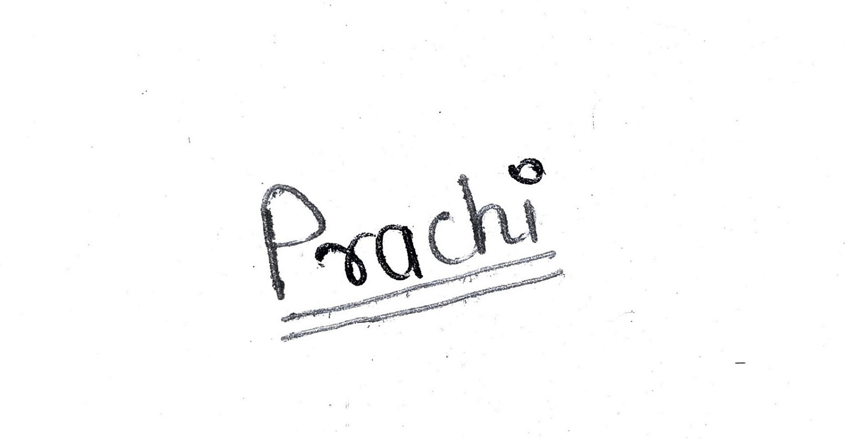

Prachi Ramane

